TASK TWO
OPERATORS AND DECISION MAKING STATEMENT
1. Write a program in Python to perform the following operation:
- If a number is divisible by 3 it should print “Consultadd” as a string
- If a number is divisible by 5 it should print “Python Training” as a string
- If a number is divisible by both 3 and 5 it should print “Consultadd - Python Training” as a string.

x = 15
if (x%3)==0 and (x%5)==0:
print("Consultadd - Python Training")

elif (x%5)==0:
print("Python Training")

elif (x%3)==0:
print("Consultadd")

else:
print("Contact Rujul")

OUTPUT:
PS D:\Python> python t2.py
Consultadd - Python Training

2. Write a program in Python to perform the following operator based task:
-Ask user to choose the following option first:
- If User Enter 1 - Addition
- If User Enter 2 - Subtraction
- If User Enter 3 - Division
- If User Enter 4 - Multiplication
- If User Enter 5 - Average
-Ask user to enter two numbers and keep those numbers in variables num1 and num2 respectively for the first 4 options mentioned above.
-Ask the user to enter two more numbers as first and second for calculating the average as soon as the user chooses an option 5.
-At the end if the answer of any operation is Negative print a statement saying “NEGATIVE”
-NOTE: At a time a user can only perform one action.

def Operations():

list=[1,2,3,4]
optr = int(input("Enter 1 for Addition, 2 for Subtraction, 3 for Division, 4 for Multiplication and 5 for Average: "))
if optr in list:
num1 = int(input("Enter first number: "))
num2 = int(input("Enter second number: "))
if optr==1:
output = num1+num2
elif optr==2:
output = num1-num2
elif optr==3:
output = num1/num2
elif optr==4:
output = num1*num2
elif optr==5:
num1 = int(input("Enter first number: "))
num2 = int(input("Enter second number: "))
num3 = int(input("Enter third number: "))
num4 = int(input("Enter fourth number: "))
output = (num1+num2+num3+num4)/4
print("Result is : ", output)
if output<0:
print("Result is NEGATIVE")
Operations()

PS D:\Python> python t2.py
Enter 1 for Addition, 2 for Subtraction, 3 for Division, 4 for Multiplication and 5 for Average: 2
Enter first number: 4
Enter second number: 7
Result is : -3
Result is NEGATIVE

3. Write a program in Python to implement the given flowchart:
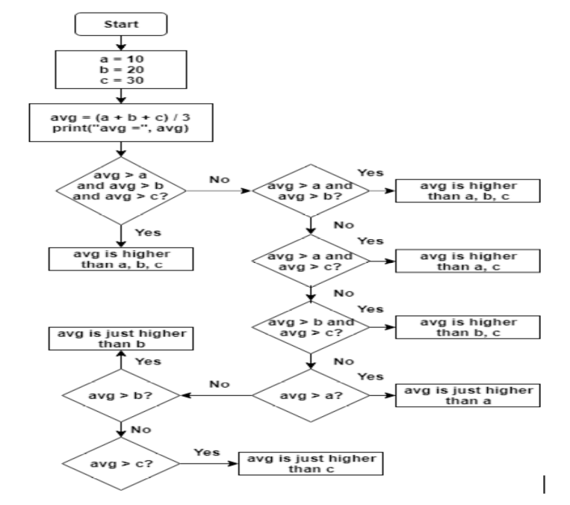

def FlowChart():
a,b,c = 10,20,30

avg=(a+b+c)/3
print("Average is: ",avg)

if avg>a and avg>b and avg>c:
message = "Average is higher than a,b,c"
elif avg>a and avg>b:
message = "Average is higher than a,b"
elif avg>a and avg>c:
message = "Average is higher than a,c"
elif avg>b and avg>c:
message = "Average is higher than b,c"
elif avg>a:
message = "Average is just higher than a"
elif avg>b:
message = "Average is just higher than b"
elif avg>c:
message = "Average is just higher than c"
print(message)
return None

FlowChart()

OUTPUT:
PS D:\Python> python t2.py
Average is: 20.0
Average is just higher than a

4. Write a program in Python to break and continue if the following cases occurs:
- If user enters a negative number just break the loop and print “It’s Over”
- If user enters a positive number just continue in the loop and print “Good Going”

while True:
user_input = eval(input("Enter any number: "))
if (user_input < 0):
print("It's Over")
break
else:
print("Good Going")

OUTPUT:
Enter any number: -5
It's Over

5. Write a program in Python which will find all such numbers which are divisible by 7 but are not a multiple of 5, between 2000 and 3200.
for i in range(2000,3200):
i==2000
if i%7==0 and i%5!=0:
print(i)

6. What is the output of the following code examples?
- x=123
for i in x:
print(i)

-It will give an TypeError: as ‘int’ object is not iterable.

- i = 0
while i < 5:
print(i)
i += 1
if i == 3:
break
else:
print(“error”)

-The output is as follows: One it reaches i==3, it breaks.
0
error
1
error
2

- count = 0
while True:
print(count)
count += 1
if count >= 5:
Break
OUTPUT:
0
1
2
3
4

7. Write a program that prints all the numbers from 0 to 6 except 3 and 6.
Expected output: 0 1 2 4 5 Note: Use ‘continue’ statement

for i in range(0,6):
if i==3 or i==6:
continue
print(i)

OUTPUT:
PS D:\Python> python t2.py
0
1
2
4
5

8. Write a program that accepts a string as an input from the user and calculate the number of digits and letters.
Sample input: consul72
Expected output: Letters 6 Digits 2

string = "consul72"

# initialized value
total_digits = 0
total_letters = 0

# iterate through all characters
for s in string:

# if character is digit (return True)
if s.isnumeric():
total_digits += 1

# if character is letter (return False)
else:
total_letters += 1

print("Total letters found :-", total_letters)
print("Total digits found :-", total_digits)

OUTPUT:
PS D:\Python> python t2.py
Total letters found :- 6
Total digits found :- 2

9. Read the two parts of the question below:
Write a program such that it asks users to “guess the lucky number”. If the correct number is guessed the program stops, otherwise it continues forever.
Modify the program so that it asks users whether they want to guess again each time. Use two variables, ‘number’ for the number and ‘answer’ for the answer to the question whether they want to continue guessing. The program stops if the user guesses the correct number or answers “no”. (The program continues as long as a user has not answered “no” and has not guessed the correct number)

luck_number = 5
while True:
number = eval(input("Enter the number: "))
if number == luck_number:
break
else:
answer = str(input("Do you want to continue again ? yes/no: "))
if answer == 'no':
break

OUTPUT:
Enter the number: 4
Do you want to continue again ? yes/no:

10. Write a program that asks five times to guess the lucky number. Use a while loop and a counter, such as
Counter=1
While counter <= 5:
print(“Type in the”, counter, “number”
counter=counter+1
The program asks for five guesses (no matter whether the correct number was guessed or not). If the correct number is guessed, the program outputs “Good guess!”, otherwise it outputs “Try again!”. After the fifth guess it stops and prints “Game over!”.
counter = 1
luck_number = 7

while counter <= 5:
user_input = eval(input("Enter the number: "))
counter += 1
if (user_input == luck_number):
print("Good guess!")
elif counter <= 5:
print("Try again!")
print("Game over!")

OUTPUT:
Enter the number: 7
Good guess!

11. In the previous question, insert break after the “Good guess!” print statement. break will terminate the while loop so that users do not have to continue guessing after they found the number. If the user does not guess the number at all, print “Sorry but that was not very successful”.
counter = 1
luck_number = 7

while counter <= 5:
user_input = eval(input("Enter the number: "))
counter += 1
if (user_input == luck_number):
print("Good guess!")
break
elif counter <= 5:
print("Try again!")
print("Sorry but that was not very successful")

OUTPUT:
Enter the number: 5
Try again!
Enter the number: 2
Try again!
Enter the number: 1
Try again!
Enter the number: 9
Try again!
Enter the number: 8
Sorry but that was not very successful

END OF TASK TWO

